What is MS Excel:

Microsoft Excel is a software program produced by Microsoft that allows users to organize, format and calculate data with formulas using a spreadsheet system. This software is part of the Microsoft Office suite and is compatible with other applications in the Office suite.

# **Features of ms excel**

Recommended Charts

Many Excel users don’t always know the best chart type for their data. With the **Recommended Charts** feature, Excel displays a collection of suggested chart types for the selected data. You’ll see a preview of how your data looks in different charts and then simply pick the one that displays your results that way you want to present.

## Instant Data Analysis: The new ****Quick Analysis**** tool helps both new and experienced Excel users find options for showing data in meaningful ways. Just select the data you want to analyze and then click on the Quick Analysis button that appears to the bottom right of your selected data (or press ****[Ctrl] + Q****).

## Instant Answers with PivotTables

Excel PivotTables are a powerful tool for analyzing, summarizing, and answering questions about your data but some users find them difficult to create. Thanks to another of the Excel 2013 new features, the **Recommended PivotTables** option, you can quickly create a meaningful PivotTable with just a click.

Pointer Shapes As with other Microsoft programs, the pointer often changes its shape as you work in Excel. Each pointer shape indicates a different mode of operation. This table shows the various pointer shapes you may see while working in Excel

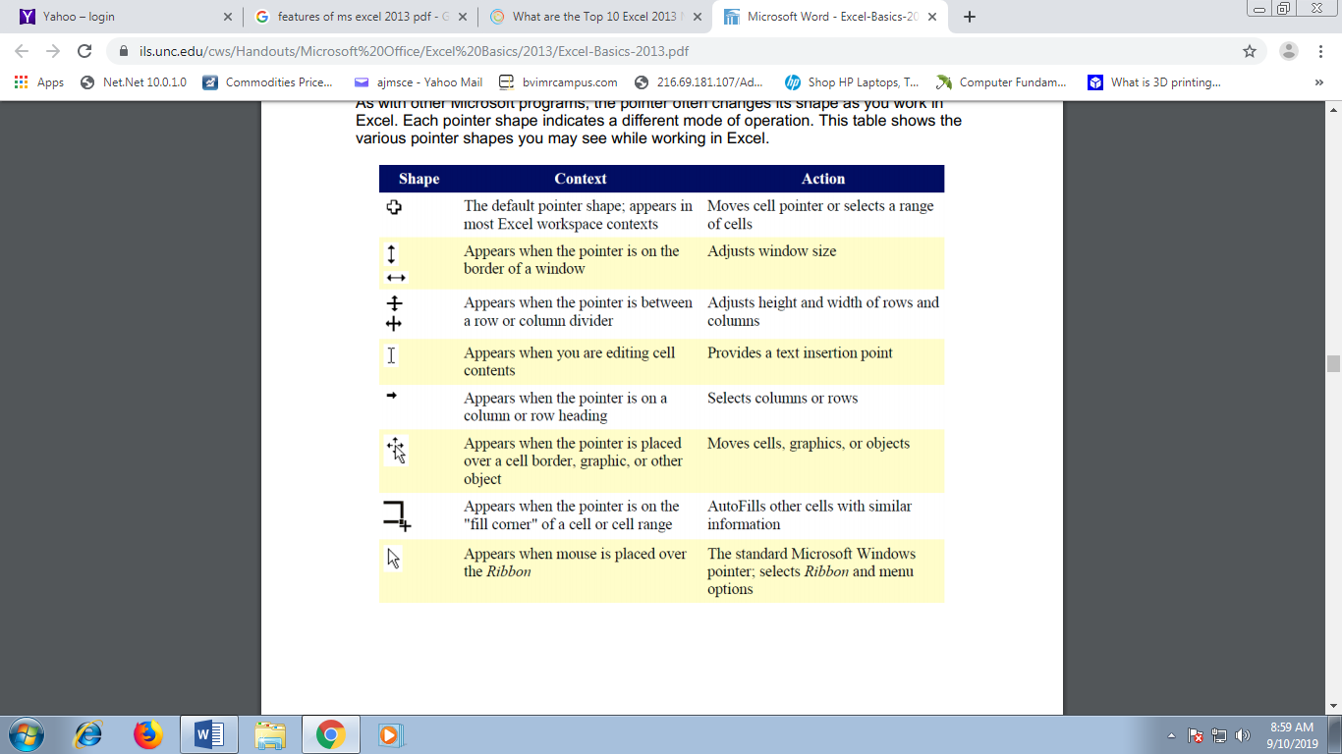

What is Cell in ms excel:

**Cells** are the small rectangular boxes that make up the spreadsheet. The boxes are the intersection of columns (A, B, C, etc.) and rows (1, 2, 3, etc.). To reference a cell, use the column the row name. For example, the cell in the first column and first row is called “A1”. All the information entered into an Excel spreadsheet is entered into cells.

**Formatting Cells**

Cells are the small rectangular boxes that make up the spreadsheet. All the information entered into an Excel spreadsheet is entered into cells. The cell width and height will usually need to be adjusted to view all the information entered into a cell. To adjust the cell width, move the mouse pointer in between two cell columns in the column header. Hold down the left mouse button and drag the mouse left to shorten the width or right to expand the width.

**Inserting Rows and Columns**

To insert a row, click on the row below where you want your new row to be (remember to click on the row number to highlight the entire row). From the “Home” tab, within the “Cells” box, click “Insert.” Select “Insert Sheet Rows.” A new row will automatically be inserted and the row numbers automatically adjusted. To insert a column, click on the column to the right of where you want your new column to be (remember to click on the column letter to highlight the entire column). From the “Home” tab, within the “Cells” box, click “Insert.” Select “Insert Sheet Columns.” A new column will automatically be inserted and the column letters automatically adjusted.

**Basic Formulas**

Excel can calculate basic equations like addition, subtraction, multiplication, and division. Let’s say you just want to add two numbers, with the answer appearing in a particular cell. (As you may remember, all formulas begin with an = sign. This lets Excel know that you are entering a formula.) To write a formula that adds two numbers together (for example, 181 + 376): 1. Click on the cell where you want the answer to the equation to appear. 2. Begin by typing the = sign. 3. Type the numbers you want to add separated by the + sign (without spaces): 181+376. 4. Your entire equation should look like this: =181+376 5. Press the Enter key. 6. You will now see the sum appear in the cell – in this case, 557.

AutoSum and Excel Equations One of the most powerful features of Excel is its ability to perform basic math functions on data. Excel can add, subtract, multiply, divide, find the average, and perform general counting functions on the numerical data that you enter. To enable this feature, highlight all of the cells in a column, plus one additional empty cell in which to display the result. Select the AutoSum icon from the ribbon menu: If you click directly on the ∑, Excel will automatically add up the numbers you have selected. If you click on the little dropdown arrow next to it .

A CELL  range is a group or block of cells in a [worksheet](https://www.lifewire.com/worksheet-and-workbook-3124111) that are selected or highlighted.

## Vertical Range

This vertical range is A2:A5. In this example, if you had selected the entire column A, the range would be A:A.

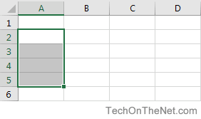

## Horizontal Range

This horizontal range is A2:C2. In this example, if you selected the entire row 2, the range would have be 2:2.

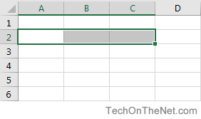

## Mixed Range

This mixed range is A2:C5. This is a collection of cells that can be from multiple rows and columns.

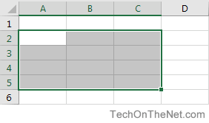

## Multiple Selection Range

This multiple selection range is A2:A3, B4:B5. This is a collection of cells that does not have to be adjacent.

